WEST COAST REGIONAL INSHORE FISHERIES GROUP (WCRIFG)

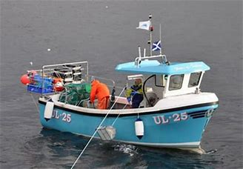

FISHERIES MANAGEMENT PLAN
2021

Revised 12/07/2021

Contents
Background | 3
Operation | 3
Development and Purpose | 5
Strategic Objectives | 5
Aims | 5
Actions & Outcomes  References | 10  13
Appendices | 14

Background
The West Coast Regional Inshore Fisheries Group (WCRIFG) is one of five regional inshore fisheries groups in Scotland and was established in April 2016 as an amalgamation of the former South West and North West Inshore Fisheries Groups. These former fisheries groups were part of a model of six RIFGs formed in 2013 with the purpose of delivering the objectives of fisheries management plans that were produced by pilot RIFGs between 2009 - 2012.
The overarching aim of WCRIFG is to improve the management of inshore fisheries, in line with the Future Fisheries Management Document, out to twelve nautical miles* and give commercial inshore fishermen a strong voice in wider marine management developments. WCRIFG is non-statutory working with inshore fisheries industry representatives, statutory bodies such as Marine Scotland and Nature Scotland, and other parties. Having regard to the Marine Scotland Inshore Fisheries Strategy 2012¹ and the National Marine Plan², the WCRIFG considers matters with the potential to impact upon or otherwise affect inshore fisheries. Specifically, WCRIFG seeks to advance, make recommendations and proposals connected to:
- The development and implementation of regional policies and initiatives relating to the management and conservation of inshore fisheries, and impacts on the marine environment to ensure there is a viable fishing industry in WCRIFG waters as well as in Scotland more generally and, the maintenance of sustainable fishing communities;
- The development and implementation of measures designed to better conserve and sustainably exploit stocks of shellfish and sea fish (including salmon) in WCRIFG waters, and to enable local fishermen, other fishermen who rely on WCRIFG waters for their livelihood, and other persons with an interest to contribute to such development; and,
- The development of proposals for and approaches to Marine Scotland, IFMAC, Marine Planning Regions, other RIFGs, and others with an interest in the West Coast fishery in relation to inshore fisheries management.
(*within Marine planning areas the RIFG remit is extended to 12 nautical miles)

Operation
WCRIFG is a non-constituted body covering inshore waters extending from Cape Wrath in the north to the national boundary with England in the Solway Firth, including the Inner Hebrides (Fig. 1). The operation of the WCRIFG is defined in the RIFG Structure and Function document³. WCRIFG operates with a Management Committee which meets at least twice per year though it may convene more frequently if required. The Management Committee is supported by four geographic subcommittees namely, Clyde, Mull & Argyll, Solway and, West Highlands & Skye*. Subcommittees include locally based members, and they help to develop aims and objectives as well as undertake other activities such as projects pertaining to their respective areas. The geographic subcommittees are selected in recognition of differences in inshore fishing cultures within each respective area but also to coincide with current and future marine planning partnership areas. These areas are also largely consistent with current Fisheries Local Action Groups (FLAGS) which are responsible for recommending applications for funding. These include Argyll & Ayr FLAG, Dumfries & Galloway FLAG, and, Highland & Moray FLAG.
*In 2021 it is proposed that the West Highland and Skye Sub Group be split, thereby creating two Sub Groups. One Ardnamurchan Point to Torridon, including the Small Isles and Skye and Raasay, and the other from Torridon to Cape Wrath
Figure 1.
Regional Inshore Fisheries Groups
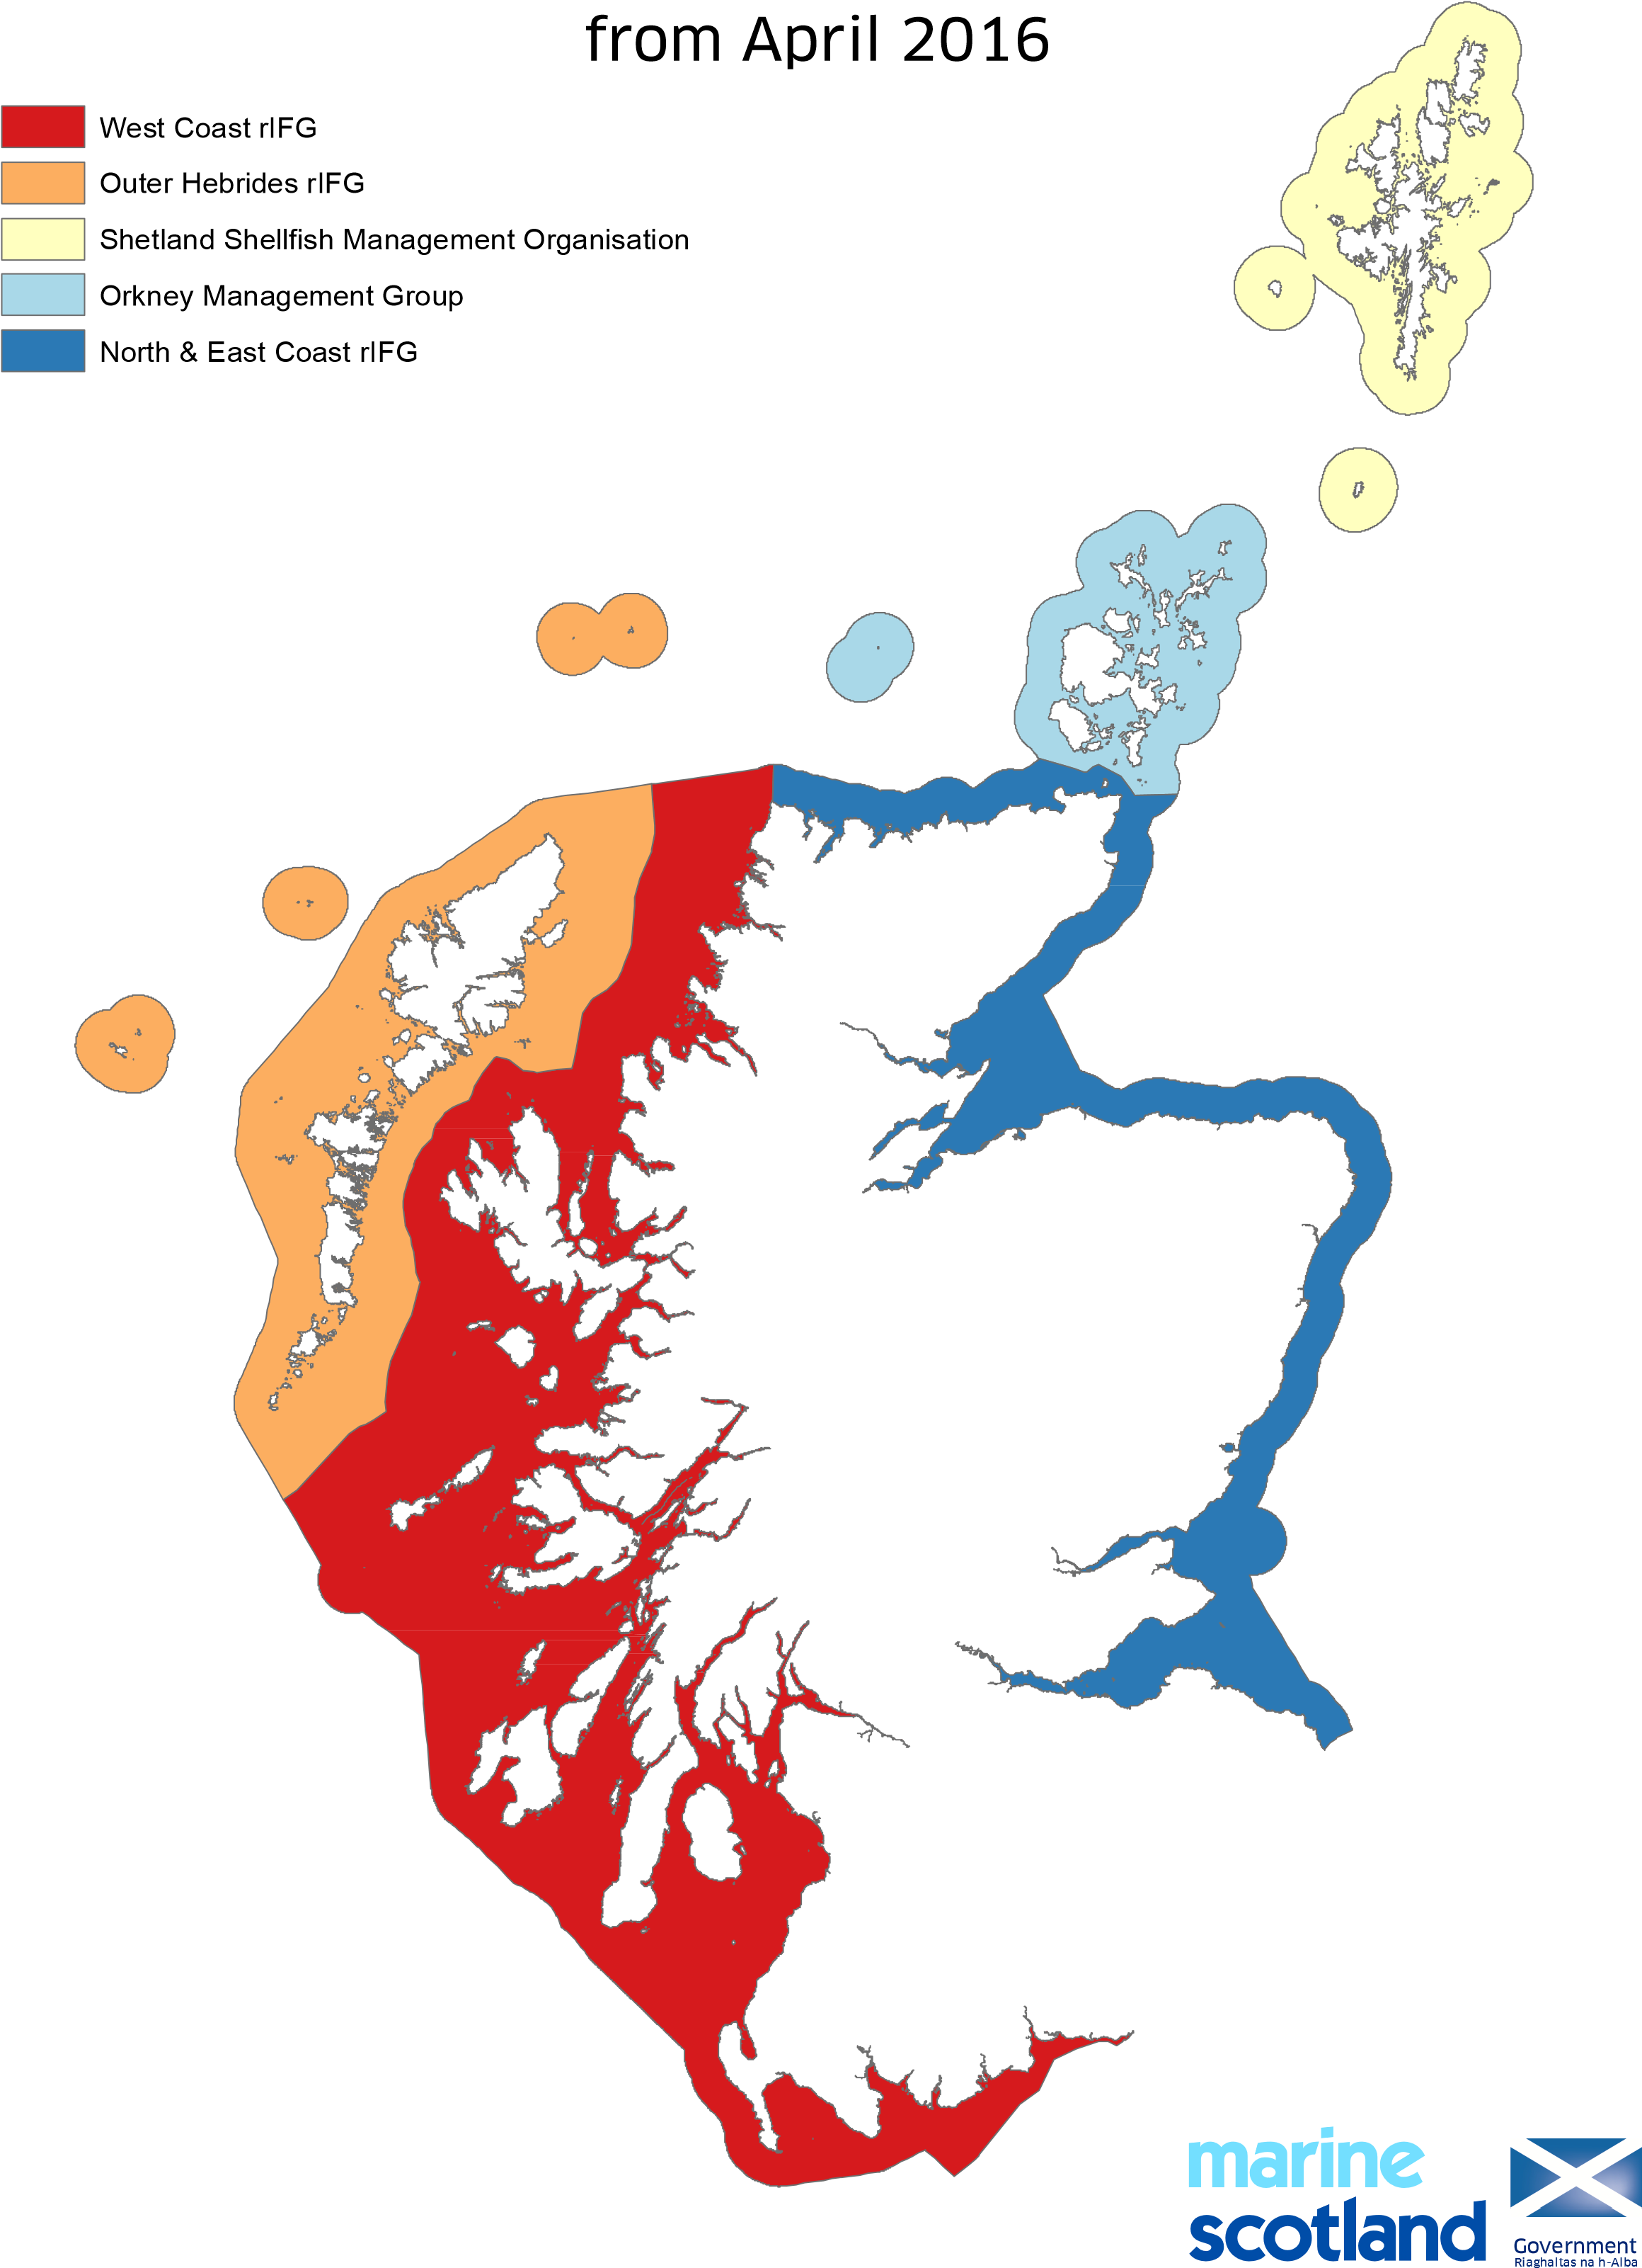The Scottish

The WCRIFG Management Committee or Subcommittees may establish working groups to deal with specific issues that require greater input than can be resolved during committee meetings. Working groups are generally short lived and task and finish in nature; the membership will generally be determined by the Chair in consultation where appropriate with committee members. The findings of working groups are reported to the respective committee from which they were formed and the outcomes of each Subcommittee are reported to the WCRIFG Committee. The process of reporting everything to the WCRIFG Committee ensures consistency and transparency. Reporting mechanisms agreed by the management and subcommittees include face to face meetings and video meetings as well as electronic correspondence. Notes or minutes of all WCRIFG Management Committee meetings provide records of each event and are made publicly available on the WCRIFG Web site.

Development and Purpose
This plan has been developed from various inputs including the review of SWIFG & NWIFG plans published in 2012 namely Clyde³, Small Isles and Mull⁴, and North West⁵. Contributions from facilitated workshops held during 2016 (Mull, Newton Stewart & Inverness) as well as committee and subcommittee meetings have also informed the plan. Unlike earlier plans, this fisheries management plan applies to the entire WCRIFG region including areas such as Solway which was not included in the original pilot RIFG planning process. The latest Fisheries Management Plan is a flexible rolling document which will be subject to ongoing review by the WCRIFG Management Committee allowing it to evolve as actions are addressed or new developments or issues arise.
Primarily, the plan aims to deliver the sustainable use of natural resources recognising national and international obligations, and safeguarding fish stocks while optimising the economic return for inshore fisheries and dependent communities. To achieve this there are overarching strategic objective which are consistent with earlier RIFG plans as these generally remain current.

Overarching Strategic Objectives
- Biological - to conserve, enhance and restore commercial stocks in inshore waters and the supporting ecosystem.

- Economical - to optimise long term and sustained economic return to local coastal communities that are dependent on inshore fisheries, and to promote quality initiatives.

- Environmental - to maintain and restore the quality of the inshore marine environment.

Aims
Aims define areas that have been identified for consideration or action within the plan. Aims have been split into those which are general applying to the entire WCRIFG area and others that are geographically specific and are presented under the respective subcommittee areas to which they apply. Where aims relate to more than one subcommittee area but not the entire WCRIFG region they are repeated under the respective subcommittees to which they apply.

General Aims
- Work with and inform agencies such as Marine Scotland and Nature Scot in the development of management plans for MPAs/SACs/PMFs to ensure that statutory processes take full account of inshore fishing interests in designation and management processes.

- Respond where appropriate to marine statutory consultations such as marine licences, aquaculture proposals, marine planning, etc, where WCRIFG members submit details for responses or alternatively in line with WCRIFG position statements.

- Encourage fishermen to bring forward and view local fisheries issues as part of a wider network of management including Marine Scotland, Marine Planning Partnerships and national forums such as IFMAC.

- Develop position statements that are consistent with the objectives of the National Marine Plan but also reflect the expectations of the WCRIFG. Position statements will be appended to this plan and will be used to advise parties proposing developments in coastal waters of WCRIFG’s general stance though these may also be supported by site specific criteria. The following areas have been identified for position statements:

- Marine Cable Laying contracts
- Coastal/Marine Pipeline contracts
- Marine & Coastal Construction contracts
- Dredging & Deposits in Marine/Coastal Waters
- Port & Harbour Developments
- Inshore Recreational Developments
- Offshore Renewable Developments (wind/tidal)
- Fish Farming (all types)
- Sea Weed Farming
- Non-native Invasive Species
- V-Notching
- Creel Escape Panels
- Litter
- Pollution
- RIFG Aquaculture Position Statement

- Explore options for scallop management planning in west coast waters following voluntary closures imposed by WCRIFG in Loch Sunart in 2016. Concerns of ingression of large numbers of vessels and heavy impacts mean that measures are required as a priority to minimise effects and conserve resources.

Local Aims

Clyde

- Through the Chair engage as a member of the Clyde Marine Planning Partnership (CMPP). Objectives of membership are to ensure that the social and economic importance of fisheries together with key natural and infrastructure resources required to sustain fishing activities are clearly defined. Ensure that WCRIFG objectives contained in this plan inform the development of plans and activities pertaining to CMPP and Clyde 2020.

- Ensure that that all fisheries proposals/issues raised by or via the CMPP are reviewed by the WCRIFG Clyde Subcommittee before progressing to the CMPP.

- Through the Chair the WCRIFG will participate as a member of Clyde 2020 subgroup of CMPP with the aim of ensuring that all fisheries issues are scrutinised by the WCRIFG prior to progressing via the CMPP.

- There are a number of areas that require addressing but there needs to be prioritisation and a recognition of the resources required to take issues forward. It is believed that within the Clyde considerable areas have been lost to fishing as the result of other developments. Mapping of these together with areas that remain active fisheries grounds will provide a useful resource to demonstrate impacts that there have been on the industry i.e. fishing grounds lost and highlight areas where it would be undesirable to see future impacts/losses. To begin to achieve this and other aims as listed below technical support is required. This might be obtained by using RIFG outreach support or seeking to employ a person supported by grant funding

- Scallop stock assessment

- Crab tagging as part of a collaborative project being led by Orkney. Objective is to tag brown crabs to study movements, spawning etc.

- Investigate the system of a mixed fishery returned by enabling boats to vary catches to take the strain off of single species – e.g. go from prawns – herring - mackerel – squid

- Prawns – increase minimum tail size

- Promotion and marketing – promotion of Clyde caught products, problems getting Clyde catches to market so look at infrastructure and transport in order to get catches to market efficiently, reduce or even eliminate variability – potential links with Argyll and Ayrshire economic forums

- Investment – help boats diversify, help get young people into the industry, build new types of vessels e.g. three man ringed nets ideal for Clyde

- Investigate fish feed levels in the Clyde which are believed to be low. Is this the reason stocks are so low?

- Investigate the impact of creels on benthic habitats particularly where areas have become saturated with creels.

Mull & Argyll
- Develop a strategy to sustain and secure a profitable industry to ensure local control of fisheries through establishing projects or practices consistent with sustainable commercial fisheries management.

- Explore the potential for the development of locally based sustainable fisheries management measures including gear conflict resolution in waters West of Mull. The objectives are (a) to implement measures that will help conserve and enhance scallop stocks by controlling effort and, (b) protect, conserve and minimise gear conflict in a defined crabbing area. Demonstration and research for a 3-5 year period will allow data to be gathered and help inform future local fisheries management.

- Explore options to maximise the potential to acquire future funding to support issues in objectives (i) & (ii) above

- Crab tagging as part of a collaborative project being led by Orkney. Objective is to tag brown crabs to study movements, spawning etc.

Solway
- Explore the potential for an industry led feasibility project to re-establish the Solway cockle fishery under strict management criteria. Opportunity for an industry led project which would entail as study in a defined area of the Solway cockle fishery for the purpose of determining measures that might lead to the sustainable management of the cockle fishery. The study would allow for some commercial fishing by boat in order it is self-financing though, depending on what other measures the project applicants wish to include in the study, there may be potential for other financial support.

- Review the findings of the Solway RIFG projects report (lobster v-notching, DNA testing (Lobsters) and, creel escape panels) and explore opportunities for further developments.

- Explore options to maximise the potential to acquire funding to support issues in objectives (i) & (ii) above

- Undertake an annual review of the Solway Code of Conduct (Gear Conflict) in consultations with signatories prior to the opening of the scallop season. This process now in its tenth year has been largely successful in minimising potential gear conflict and Solway based WCRIFG members are keen to see the Code continue.

- Collaboration project with other stakeholders to deliver on (i) above and investigate the value of cockle re-layering. A proposal is being developed whereby re-layering of cockle spats take place as a study to evaluate if this methodology provides a viable opportunity to stock cockles and allow a commercial fishery to be sustained. It has been suggested that re-layering and the commercial study in (i) above be managed as a joint project combining both aspects within a single study.

- Explore the potential to develop a small fin fish/mixed fishery in the Solway that would allow a local catch to be taken by small inshore vessels for processing in locally land based facilities.

West Highlands & Skye
- Evaluate and restructure the West Highlands and Skye Sub Group into two separate groups, namely:
West Highland Sub Group, covering: Ardnamurchan to Torridon including Isle of Skye, Rassay and the Small Isles.
North West Sub Group, covering from Torridon to Cape Wrath
- Explore options to maximise the potential and to acquire funding to support issues in objectives for the new sub groups above or other developments which evolve during the life of this plan

Resources
The achievement of several issues in this plan will in part depend on successfully obtaining the support of not only WCRIFG members but other partners too. Where necessary grant funding will be needed to facilitate actions and access to RIFG outreach officer support will be imperative. Clyde Subcommittee members have discussed the possibility of seeking to employ technical support if grant funding can be obtained to facilitate this.
Opportunities will be taken to apply for funding support. There are three separate FLAGs covering the WCRIFG to which applications for funding might be submitted. FLAGS include Highlands and Moray, Argyll & Ayrshire and, Dumfries & Galloway; these FLAGs largely correspond with the areas covered by WCRIFG subcommittees and there is the potential to undertake collaboration projects between different FLAGs. Funding may also be available centrally for certain proposals.

Table 1: Actions & Outcomes
Actions | Aims | Partners |  |  |  | Financial & Other Support | Outcomes & Deadline for Completion
Following voluntary closures in Loch Sunart in 2016 & 2017 develop a plan of action which will encourage scallop stock conservation. Explore potential areas that could be subject to agreed closure | General (5) | WCRIFG members, Marine Scotland |  |  |  | N/A | Review the position with respect to voluntary closures until legislation is reviewed by the Scottish Government bringing Loch Sunart’s scallop season opening, into line with other West Coast waters (i.e. 1st November)
Chair to represent WCRIFG on CMPP | Clyde (1), (2) & (3) |  |  | CMPP |  | N/A | Chair represents WCRIFG on CMPP Board and steering committee and on the Clyde 2020 Advisory Group to ensure that WCRIFG members contribute to informing Marine Planning and Clyde 2020 developments  Ongoing
Produce a mapping resource to demonstrate areas lost to fishing by other developments activities and show areas where fishing continues and grounds need protection from creeping development activities | Clyde (4) |  |  | WCRIFG, CMPP |  | EMFF | Highlight areas lost to fishing and areas where fishing continues. A resource that can be used to respond to development proposals, applications etc  2018  Ongoing
Implement a pilot project with a view to it running from Oct 2018-Jan 2019 & Oct 2019 – Jan 2020 | Mull and Argyll (2) & (3) |  |  | WCRIFG Subcommittee, MICT, Marine Scotland, SNH, RIFG Outreach support |  | EMFF | A two year trial comprising four months from 1 October each year (2018 & 2020) will allow spatial separation within a crab box West of Mull managed by the local fishing group. Scallopers will have access to area for other eight months each year.  Ongoing
Crab tagging as part of a study being led by OFA | Clyde (6) & Mull and Argyll (4) |  |  | WCRIFG members, other IFGs particularly OFA |  | N/A | Subject to successful funding bid led by OFA enable crab tagging to begin 2018. Will be used to complement above crabbing pilot.  Done
Investigate the development of a cockle harvesting project involving the commercial sector to explore if controlled fishing by boat in selected areas of the Solway can be done sustainably and managed by cocklers | Solway (1), (3) |  |  | WCRIFG Solway Cockle work Group Marine Scotland, commercial cockle sector |  | Outreach Support | Consultant employed using outreach support and in consultation with partners to produce a report/findings early 2021  Ongoing
Collaboration project with the stakeholders to trial relaying of cockles in a selected area(s) of the Solway | Solway  (5) |  |  | WCRIFG Chair, Nature Scot, RSPB, SFP, University of the SW, D&GFLAG Committee |  |  | Project proposals submitted  Ongoing with above project
Review Solway Code of Conduct to maintain good operational practice | Solway (4) |  |  | Solway WCRIFG Subcommittee |  | N/A | Review to be completed Annually
Investigate potential for the development of a small localised mixed fishery entailing local processing/marketing. | Solway (6) |  |  | WCRIFG Solway Subcommittee |  | N/A | Preliminary investigational review to be undertaken to see if a quota can be obtained.  Requests for quota to include sea bass.  Ongoing
Potential spatial management of local fishery to manage sustainably and minimise gear conflict. | West Highlands & Skye (1) & (2) |  |  | WCRIFG Subcommittee Marine Scotland  Outreach Support |  | EMFF | Develop a detailed plan for a demonstration trial with potential research within a defined area (Inner Sound)  Under review
Investigate potential scallop management strategies in waters west and south of Mull (4 sites) to ensure sustainable management of stocks. Will include potential measures including increased MLS of scallops taken from MPAs | General (5) |  |  | WCRIFG using outreach support |  | Outreach | Consultant to be employed to produce proposals following collaboration with fishing industry for consideration by WCRIFG.  Project extended
Respond to consultations e.g. cable contracts, licence applications e.g. fish farming, MPA, SAC/SPA developments on behalf of WCRIFG members representing views and concerns. Position statements may be used where available and no site specific comments are obtained from RIFG members | General (1) & (2) |  |  | WCRIFG |  | N/A | Ensure that views and/or concerns of WCRIFG members are highlighted via formal consultation processes or pre-application stages  Ongoing
Creel Number Limitations.  Investigate and implement | General  (4)(5)(6) |  | WCRIFG  Marine Scotland |  |  |  | Set maximum creel numbers limit for West Coast, based on discussions through Sub Groups, and liaise with Marine Scotland on implementation
West Highlands and Skye Sub Group | WHSG  (6) |  | WCRIFG |  |  |  | Create two new sub groups by splitting West Highland and Skye Sub Group, forming one group from Ardnamurchan Point to Torridon, including Small Isles, Raasay and Skye. Then the other Sub Group from Torridon to Cape Wrath.

References
- Scottish Inshore fisheries Strategy, Scottish Government. 2015
- Scottish National Marine Plan, Scottish Government. 2015
- Scottish Regional Inshore Fisheries Groups Outline structure and Functions, Marine Scotland. 2016
- Fisheries Management Plan, Clyde Inshore Fisheries Group. 2011
- Fisheries Management Plan, Small Isles and Mull Inshore Fisheries Group. 2012
- Fisheries Management Plan, North West Inshore Fisheries Group. 2011

Appendix 1

WEST COAST REGIONAL INSHORE FISHERIES GROUP

Position Statement on the Laying of Subsea Cables

Introduction
This Position Statement provides an overview of the WCRIFG’s views on how cable laying operations within inshore waters are undertaken. The Position Statement provides a general overview of the actions the WCRIFG expects during cabling contracts notwithstanding that in some instances site specific issues may mean other or alternative measures may be required in order to protect inshore fishing interests.

Background
The West Coast Regional Inshore Fisheries Group (WCRIFG) was established in April 2016 and is an amalgamation of the former South West and North West Inshore Fisheries Groups. Its main aim is to improve the management of inshore fisheries out to six nautical miles. WCRIFG is non-statutory but works with inshore fisheries industry representatives, statutory bodies, including Marine Scotland and other parties. Having regard to the Marine Scotland Inshore Fisheries Strategy 2012 and the National Marine Plan, the WCRIFG considers matters with the potential to impact upon or otherwise affect inshore fisheries. In particular the WCRIFG seeks to advance, make recommendations and proposals connected to:

- The development and implementation of regional policies and initiatives relating to the management and conservation of inshore fisheries, and impacts on the marine environment so as to ensure a viable fishing industry in the WCRIFG Area as well as in Scotland more generally and, the maintenance of sustainable fishing communities;
- The development and implementation of measures designed to better conserve and sustainably exploit stocks of shellfish and sea fish (including salmon) in WCRIFG waters, and to enable local fishermen, other fishermen who rely on WCRIFG waters for their livelihood, and other persons with an interest to contribute to such development; and,
- The development of proposals for and approaches to Marine Scotland, IFMAC, Marine Planning Regions, other IFGs, and others with an interest in the fishery in relation to inshore fisheries management.

Subsea Cables
Subsea cable laying contracts are increasingly occurring within Scottish inshore waters; it is recognised that the cables are an important part of the country’s infrastructure and likely to remain so into the future. However, the installation and presence of subsea cables creates risks to the safety of inshore fishing as well as damage to the marine environment. Laying subsea cables unprotected on the sea bed presents an unacceptable health and safety risk to vessels and their crews in particular if using bottom trawl. The minimum potential problem through snagging or entanglement can be tears or damage to fishing gear whereas more serious events could be the loss of a vessel and its crew.
Cables must be buried using methods appropriate to the exacting requirements of the location where the activity is to be undertaken. Where seabed substrates are unsuitable for burying cables, methods such as armouring, mattressing or rock dumping must take place to secure and make cables safe. Armouring, mattressing or rock dumping must be done in line with best engineering practices and to standards that minimise marine environmental impact and disruption to commercial inshore fishing activities.
The timing of cable laying works should be done when they are least likely to disrupt or displace commercial inshore fishing activities. Cable contracts have a long though relatively narrow footprint; cognisance of potential environmental impacts must be considered and contracts must include best practice mitigation measures to minimise damage to substrates, fauna and flora. Opportunities must be sought to ameliorate damage caused by contracts and indeed seek to improve the environment along the course of the cable, particularly where environmental productivity is poor. Improving seabed substrates or other potential features will serve to complement disturbances caused by cable installations.
Once cables have been laid there must be a programme of inspections, particularly in locations where seabed substrates are known to be unstable. Inspections will help to ensure that if cables become exposed, such as in areas where there is known to be natural seabed mobilisation, action can be taken to avoid potential issues as outlined above.

WCRIFG Position

- All subsea cables must be buried in the seabed using current best engineering guidance and practice

- Where cables cannot be buried because of unsuitable substrates, alternative protective measures such as armouring, mattressing or rock dumping must be applied using current best engineering guidance and practice

- Opportunities should be taken, where practicable and on the advice of statutory bodies, to make improvements to the environment within the footprint of the cable tract, such as opportunities for habitat improvements for lobster or other species.

- Cable contracts should be undertaken, where possible, at times when they will create minimum disturbance to inshore fishing activities.

- Where long lengths of cabling are involved, the works must be completed in stages so that the seabed in each stage is restored within a reasonable timescale.

- Programmes of inspections must be implemented to ensure that subsea cables do not become exposed leading to potential fishing hazards

- Contractors must be familiar with the best practice guidance on Fisheries Liaison for Offshore Wind and Wave developed by the FLOWW group. (http://www.thecrownestate.co.uk/media/5693/floww-best-practice-guidance-for-offshore-renewables-developments-recommendations-for-fisheries-liaison.pdf)

WCRIFG 2016, updated 2021

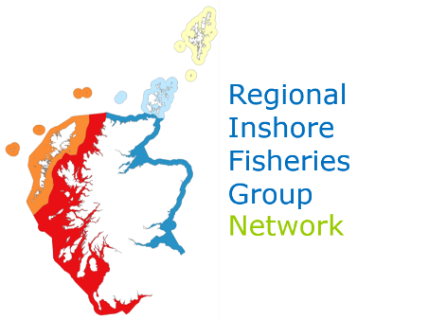

REGIONAL INSHORE FISHERIES GROUP Network

Position Statement on the Development and Expansion of Marine Aquaculture Facilities in Inshore Coastal Waters

Introduction
This Position Statement provides an overview of the Regional Inshore Fisheries Group (RIFG) views on issues concerning marine aquaculture developments within inshore waters. The RIFG management committee is responsible for maintaining a Fisheries Management Plan (FMP), which is also a key part of inputs to the Regional Marine Planning Partnership process (MPP). This Position Statement provides a general overview of issues that the RIFG network wish to avoid from aquaculture developments notwithstanding that in some instances, site specific concerns may arise beyond what has been included below.

Background

The Regional Inshore Fisheries Group network was established in April 2016 and its remit is to improve the management of inshore fisheries firstly out to six (6) nautical miles and in line with the MPP will eventually be responsible out to twelve (12) nautical miles The RIFGs are non-statutory but work with inshore fisheries industry representatives, statutory bodies, including Marine Scotland and other parties. Having regard to the Marine Scotland Inshore Fisheries Strategy, the Future Fisheries Management Strategy, the Blue Economy Action Plan and the National Marine Plan, the RIFGs consider matters with the potential to impact upon or otherwise affect inshore fisheries. In particular the RIFGs seek to advance, make recommendations and proposals connected to:

- The development and implementation of regional policies and initiatives relating to the management and conservation of inshore fisheries, and impacts on the marine environment so as to ensure a viable fishing industry in the RIFG areas and, the maintenance of sustainable fishing communities;
- The development and implementation of measures designed to better conserve and sustainably exploit stocks of wild shell and sea fish in RIFG waters, and to enable local fishermen, as well as other fishermen who rely on RIFG waters for their livelihood, and other persons with an interest, to contribute to such development; and,
- The development of the Fisheries Management Plan for use with Marine Scotland, the Marine Planning Regions including local authorities, and others with an interest in the fishery in relation to inshore fisheries management.

Aquaculture
There are ever increasing demands on inshore waters from various activities which individually and collectively have the potential to impact adversely on commercial inshore fishing interests. MPA designations, off-shore renewable energy, sub-sea cables, the Royal Navy, leisure pursuits and aquaculture are some of the activities that can conflict with the inshore sector. The complexities of the licencing process for aquaculture are many, and till now fishing has not been able to adequately deal with that. However, the RIFG involvement in the MPP should help address that issue.

There is a belief that the displacement of fishermen has happened because access to traditional historical fishing grounds has been lost to the commercial inshore sector from some of the aforementioned activities. In the worst-case scenario, we know that fishermen have seen the fishing become unviable and disposed of vessels and left inshore fishing. In some areas of the Scottish coast, inshore fishing contributes significantly to the economy of small and mainly rural or island communities and increasing pressures from the loss of access to fishing grounds, can lead to micro-economies being significantly adversely affected.

The Scottish Governments’ guidelines are clear that the FMP will contribute to the MPP and to that end the RIFG network seeks to work with all parties operating processes or developing structures in coastal waters and welcomes early collaboration. Members believe that discussions at the preliminary pre-planning stages of projects can encourage developers, such as aquaculture companies, to undertake plans in such a way that the final structures minimise impacts on inshore fishing whilst at the same time, allowing the aquaculture facility to proceed. This principle of coexistence is one which should be aspired to for all developments.

Many aquaculture installations are in locations traditionally used as fishing grounds or areas that offer shelter from prevailing adverse weather conditions. In some instances, developments have occurred in waters that inshore fishermen traditionally accessed during periods of poor weather when they were unable to fish elsewhere. If these safe fishing havens are lost, it can have a negative effect on livelihoods: it may lead to people taking greater risks by fishing in less safe waters in order to remain economically viable or, alternatively, tying up vessels and suffering financial loss.

Aquaculture facilities may present health & safety risks to inshore commercial fishermen and their vessels as the result of equipment associated with a fish farm, be it floating or submerged, resulting in snagging or other issues. Again, early consultation with local inshore fishermen can avoid issues arising in this regard.
It is not only the physical structures that affect the fishing industry. Medication used in fish farming often targets crustaceans (sea lice are crustaceans), meaning commercially fished species like nephrops can be impacted. Many fishermen have reported finding decreased catches of nephrops around farms. There are concerns that there are cumulative effects due to chemicals being distributed wider than previously thought affecting areas several kilometres from farms and, where there are several fish farms operating in relatively close proximity, these issues can be exacerbated. Besides that, deposits of excess food and fish waste on the seabed could create anoxic conditions that lead to ‘dead-zones’ under the farms. This prevents the areas from being commercially fished even after the farms are removed and until recovery occurs. Ideally, using the “polluter pays” principle, and the precedent in other licences, the farm owners should be obliged to leave the sea-bed in the condition they found it in.

RIFG network Position
- When proposing the siting of a new aquaculture development or an extension to an existing facility, developers (fish farming companies) should contact the relevant RIFG via the Chair at their earliest opportunity; preferably at the pre-planning/pre-licensing stages.

- Data exchange between individual aquaculture companies and the fishing industry to identify areas that will not affect the inshore fishing industry, will be facilitated by the knowledge in the FMP.

- Aquaculture developers must seek to take cognisance of local inshore fishing concerns and discuss with the RIFG how mitigation might be achieved in the context of aquaculture installations or expansions.

- Developers must seek to locate and design proposals in a way that minimises impact on local inshore commercial fishing interests. This can best be done by working with the RIFG, and the MPP giving due consideration to the FMP when deciding on aquaculture licences.

WCRIFG
Original version May 2019, updated March 2021, updated April 2021

